**DATA VISUALIZATION WITH PYTHON**

**Week 1 - Introduction to Data Visualization Tools**

* Introduction to Data Visualization
* Introduction to Matplotlib
* Basic Plotting with Matplotlib
* Dataset on Immigration to Canada
* Line Plots
* Lab: Introduction to Matplotlib and Line Plots
* Quiz: Introduction to Data Visualization Tools

**Week 2 - Basic and Specialized Visualization Tools**

* Area Plots
* Histograms
* Bar Charts
* Pie Charts
* Box Plots
* Scatter Plots
* Bubble Plots
* Lab: Basic Visualization Tools
* Lab: Specialized Visualization Tools
* Quiz: Basic Visualization Tools
* Quiz: Specialized Visualization Tools

**Week 3 - Advanced Visualizations and Geospatial Data**

* Waffle Charts
* Word Clouds
* Seaborn and Regression Plots
* Introduction to Folium and Map Styles
* Maps with Markers
* Choropleth Maps
* Lab: Advanced Visualization Tools
* Lab: Creating Maps and Visualizing Geospatial Data
* Quiz: Advanced Visualization Tools
* Quiz: Visualizing Geospatial Data
* Peer-review Assignment

Why Build Visuals?

* 1. For exploratory data analysis
  2. Communicate data clearly
  3. Share unbiased representation of data – sharing with other data scientists
  4. Use them to support recommendations to different stakeholders

Best Practices

1. Less is more Effective
2. Less is more Attractive
3. Less is more Impactive

Introduction to MATPLOTLIB

1. John Hunter (1968-2012)
2. Developed originally as an EEG/ECoG visualization tool
3. Analogous to Matlab scripting interface
4. Matplotlib Architecture
   1. Backend Layer (FigureCanvas, Renderer, Event)
   2. Artist Layer (programming paradigm for writing a web application server or UI application or a script to be shared with other developers)
   3. Scripting Layer (pyplot)

BACKEND

1. FigureCanvas: matplotlib.backend_bases.FigureCanvas
   1. Encompasses the area onto which the figure is drawn
2. Renderer: matplotlib.backend_bases.Renderer
   1. Knows how to draw on the FigureCanvas
3. Event: Matplotlib.backend_bases.Event
   1. Handles user inputs such as keyboard strokes and mouse clicks

Artist Layer

1. Comprised of one main object – Artist:
   1. Knows how to use the Renderer to draw on the canvas
2. Title, lines, tick labels, and images, all correspond to individual Artist instances
3. Two types of Artist objects:
   1. Primitive: Live2D, Rectangle, Circle and Text
   2. Composite: Axis, Tick, Axes, and Figure
      1. FIGURE: top level matplotlib object that contains and manages all the elements in the given graphic
      2. AXES: where most of the matplotlib API plotting methods are defined
4. Each composite artist may contain other composite artists as well as primitive artists (e.g. a figure artist will contain an axes artists as well as a rectangle or a text artist)

Using the Artist Layer – trying to generate a histogram of data

* + - 1. Import FigureCanvasAgg from backend_agg and attach the figure artist to it
         1. AGG: Anti-Green Geometry
      2. Import Numpy library to generate the random numbers
      3. Create an axes artist – added automatically to the figure axes container fig.axes
         1. (111 : matlab convention. Creates a grid with 1 row and 1 column and uses the first cell in that grid for the location of the new axes)

1. Call the Axes method “hist” to generate the histogram
   1. Hist creates a sequence of rectangle artists for each histogram bar and adds them to the axes container
   2. Ax.hist(x, 100): 100 means create 100 bins
2. Finally, we decorate the figure with a title and save it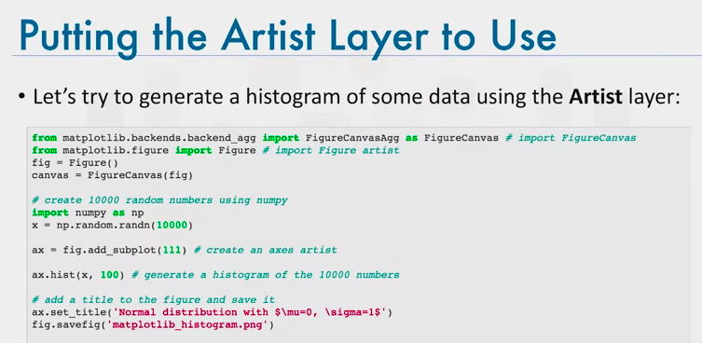

Scripting Layer

* + - 1. Comprised mainly of pyplot, a scripting interface that is lighter (on coding) than the Artist layer. Automates the process of defining a canvas and defining a figure artist instance, connecting them.
      2. Below is how to generate the same histogram of 10000 random values using pyplot:

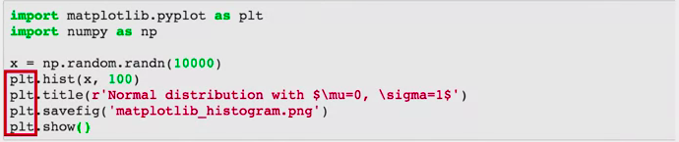

* + - 1. [www.aosabook.org/en/matplotlib.html](http://www.aosabook.org/en/matplotlib.html)

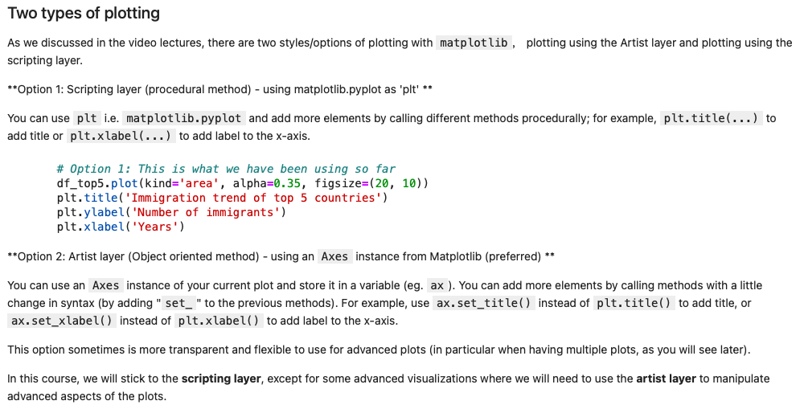

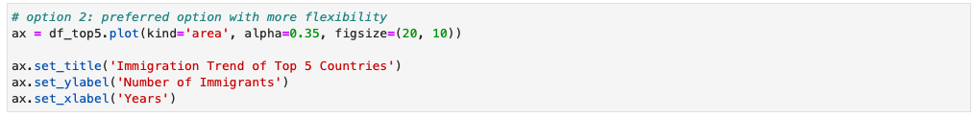

Basic Plotting with Matplotlib

1. Well established data visualization library that is supported in different environments
   1. Python, ipython shell, web-application servers, graphical user interface toolkits
2. Using Jupyter Notebooks: Import matplotlib as plt
   1. You can create almost any visualization with the Plot Function

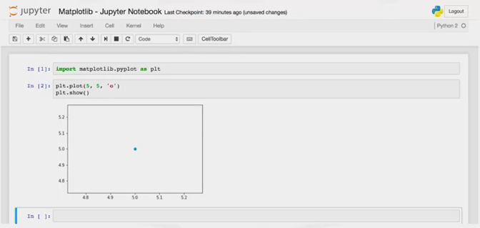Here the plot is created in-browser:

Here the plot is created using inline  
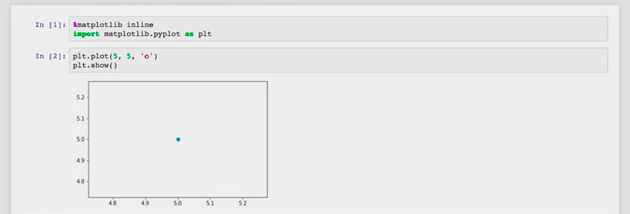

1. Matplotlib Backends – Inline
   1. %matplotlib_inline
   2. Magic function will begin with %
   3. Enforce plots to be rendered within the browser you pass in the “inline” function
   4. Cannot modify the figure once it is rendered
2. Matplotlib Backends – Notebook
   1. %matplotlib_notebook
   2. Overcomes the limitation of modifying graphics
   3. If a plt function is called, it checks if an active figure exists and any functions called will be applied to this figure
   4. If a figure does not exist it render a null figure
3. Matplotlib – Pandas
   1. Pandas has a built-in implementation of it
   2. Plotting in pandas is as simple as calling the plt function on a given panda series or dataframe

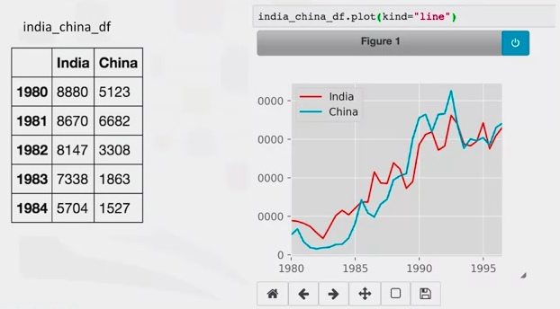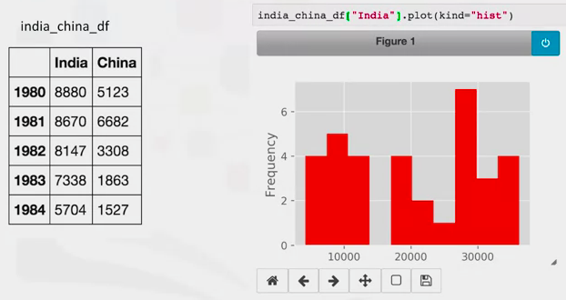

Dataset on Immigration to Canada

* 1. Population Division of the United Nations piled data pertaining to 45 countries
  2. For each country, annual data on the flows of international migrants is reported in addition to other metadata
  3. We will work primarily with UN data on immigration to Canada

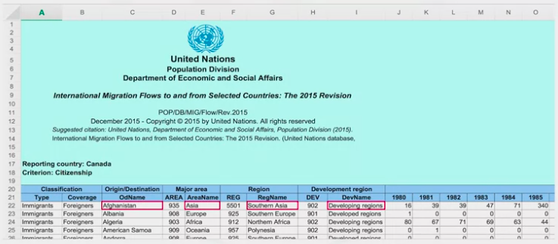

* 1. First 20 rows irrelevant info
  2. Row 21 contains the labels of the columns
  3. Following, each row contains metadata of the country (red)

Read Data into Pandas Dataframe

1. Import pandas library and xlrd library which extracts data from excel spreadsheet files
2. Call the pandas function pd.read_excel to read into pandas dataframe
   1. Dataframe called df_can
   2. Skipping the first 20 rows

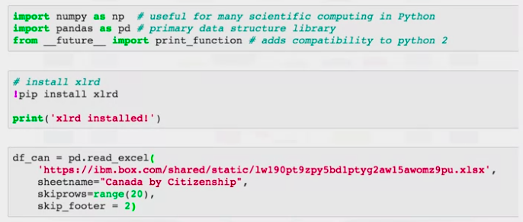

Display Dataframe

1. To ensure it has been properly imported use the df_can.head() function

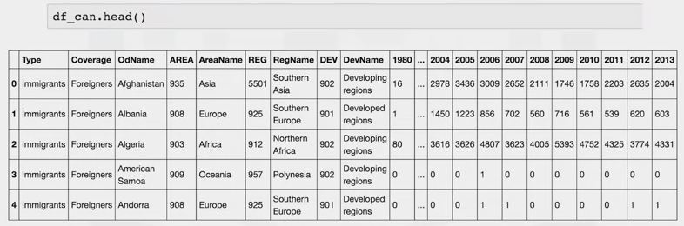

Line Plots

1. When to use a line plot?
   1. When you have a continuous dataset and interested in visualizing the data over a period of time
   2. Line plot will depict a trend, which can be researched for justification, obvious anomalies or changes
   3. E.g. 2010 Earthquake in Haiti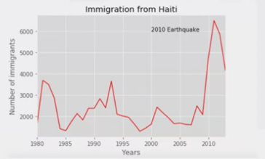
2. Data Analysis and Processing

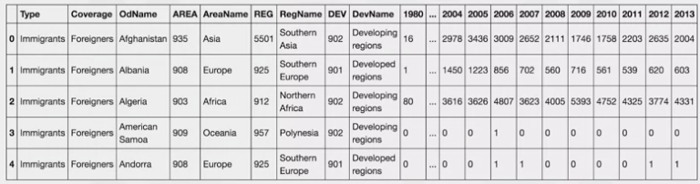

Processed spreadsheet:

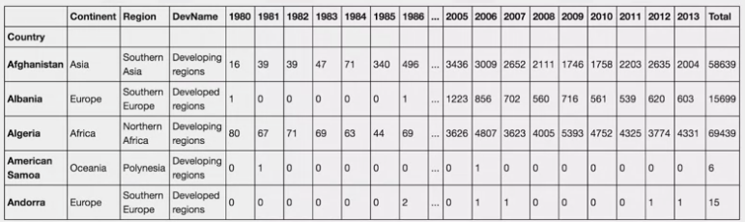

* 1. Country name becomes the index of each row – making querying specific countries easier
  2. Extra column representing the cumulative sum of annual immigration from each country

1. Creating Line Plots
   1. Import matplotlib as mpl and its scripting interface as matplotlib.pyplot as plt
   2. Call the plt function on the loc corresponding to ‘Haiti’
   3. Set kind = ‘line’ to generate line plot
   4. Use “years” in order to exclude the column of total immigration added
   5. Give it a title and label axes
   6. Call plt.show()

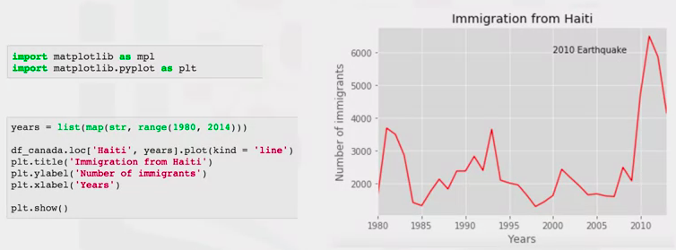

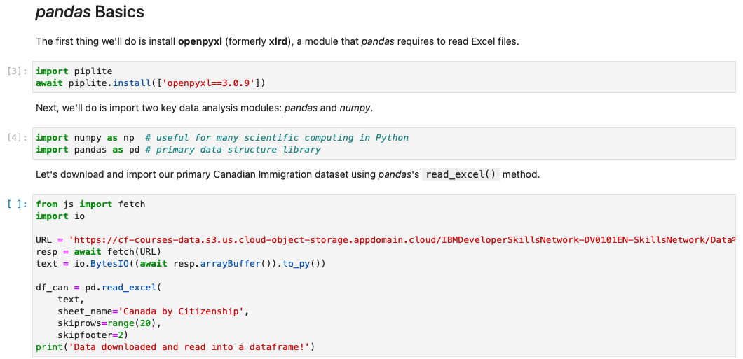

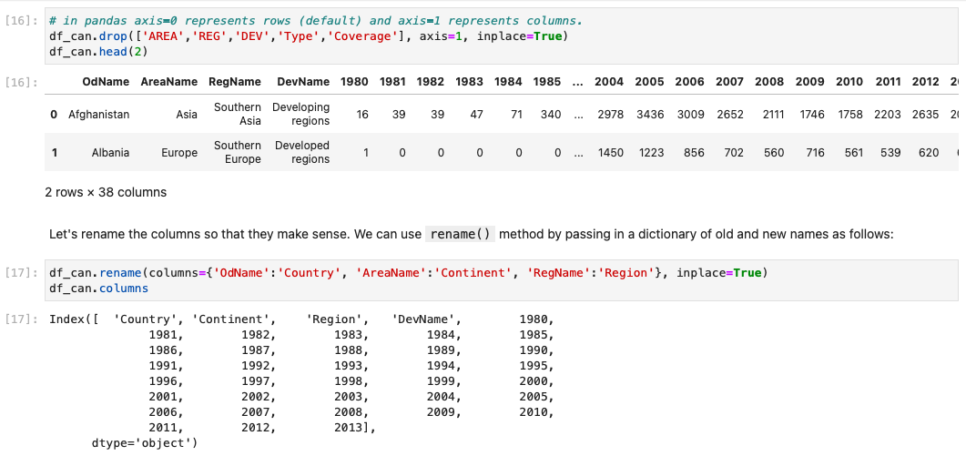



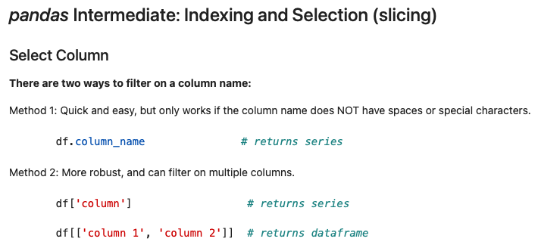

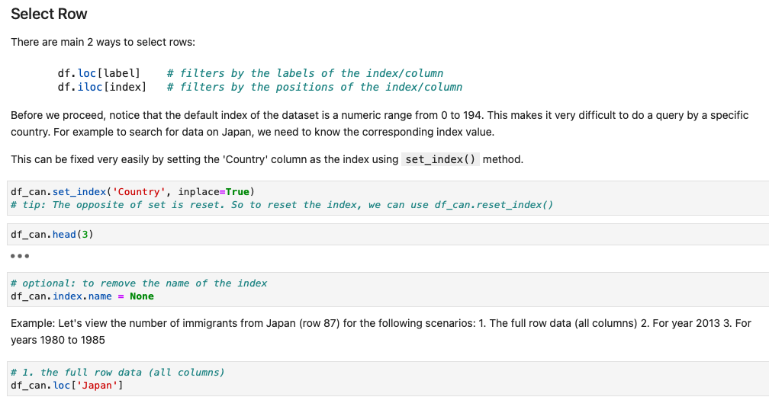

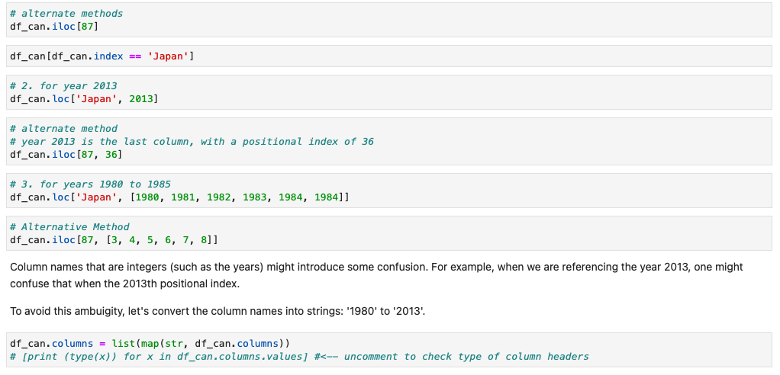

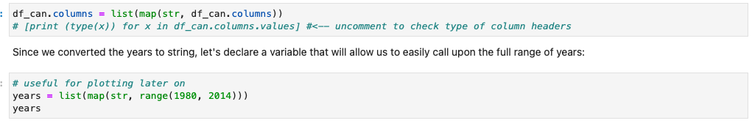

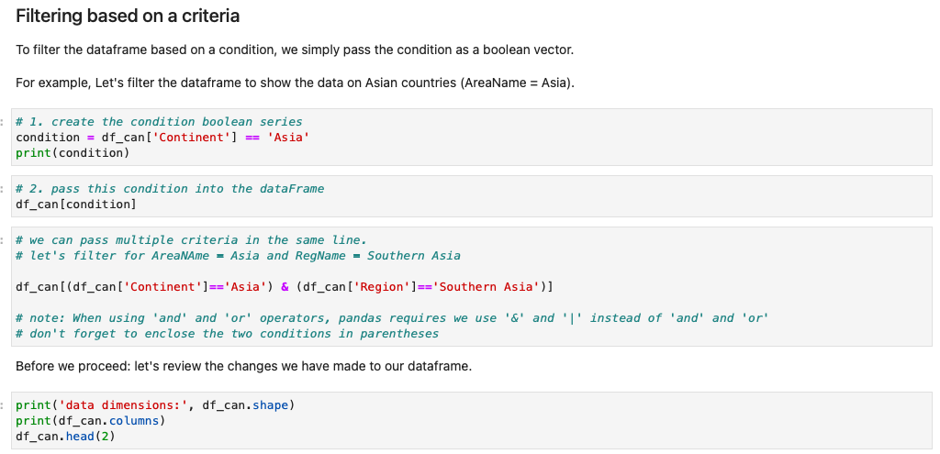

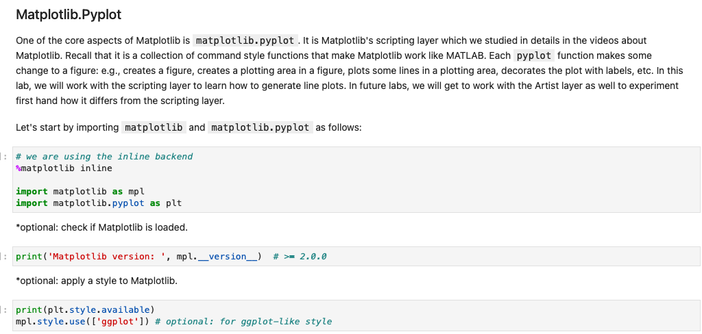

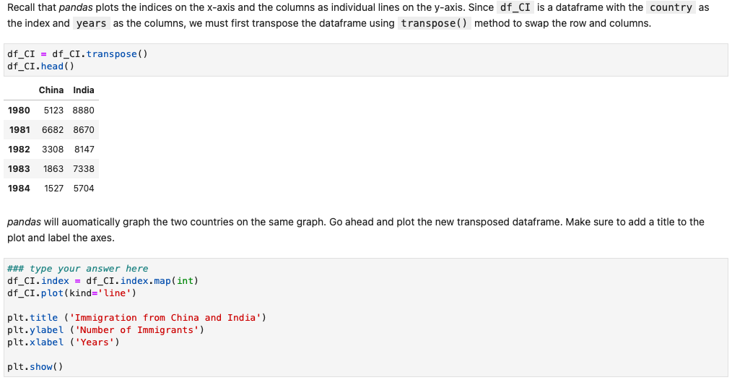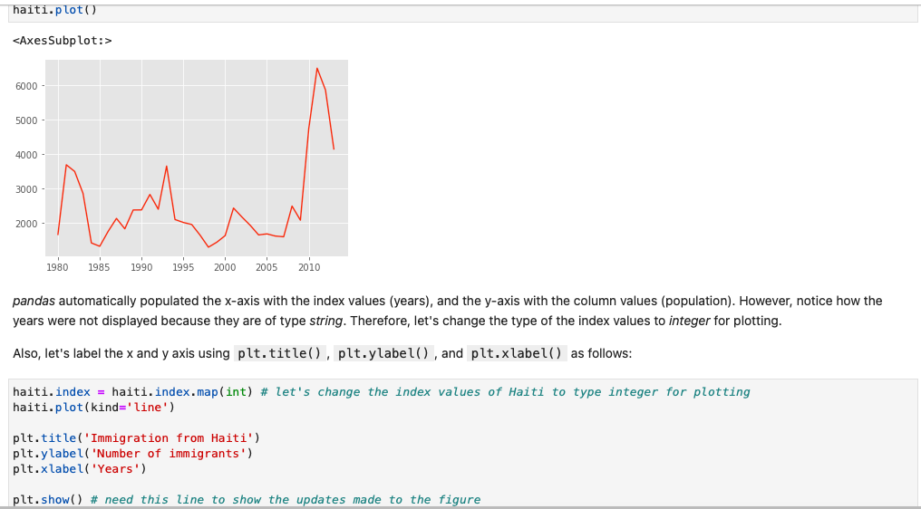

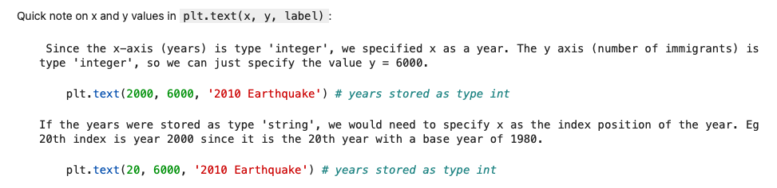

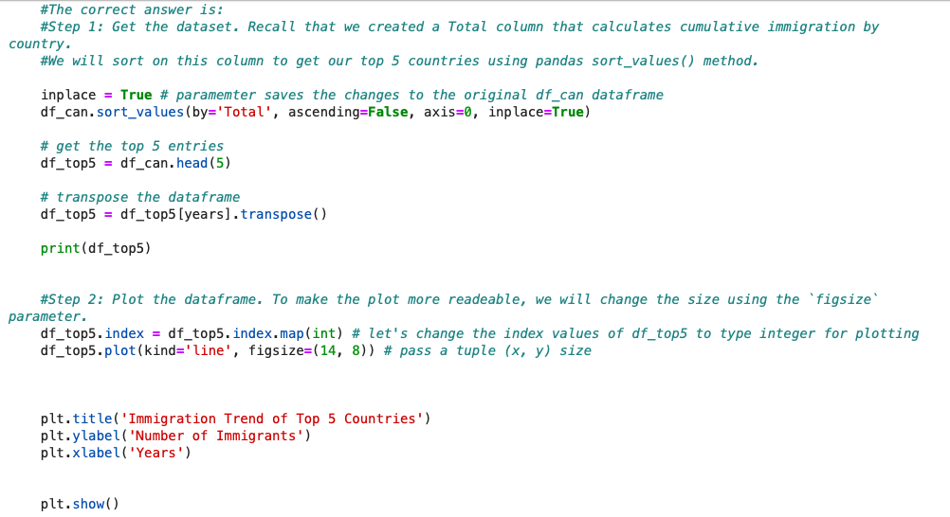

**BASIC VISUALIZATION TOOLS**

Area Plot

* 1. A.K.A. area chart or area graph
  2. Used to represent cumulated totals using numbers or percentages over time
  3. Is based on the line plot

Generating Area Plots

1. Countries with the highest numbers of immigrations to Canada
2. Sorting the dataframe in descending order from the selected dates



1. Sort_values function
2. Still need to do the following:
   1. Create a new Dataframe of only the top 5 countries
   2. Exclude total column
   3. Years must be plotted on the horizontal axis and the annual immigration on the vertical axis (matplotlib plots indices on the horizontal axis)

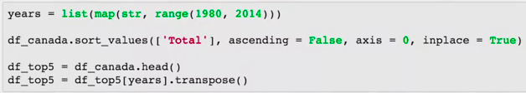

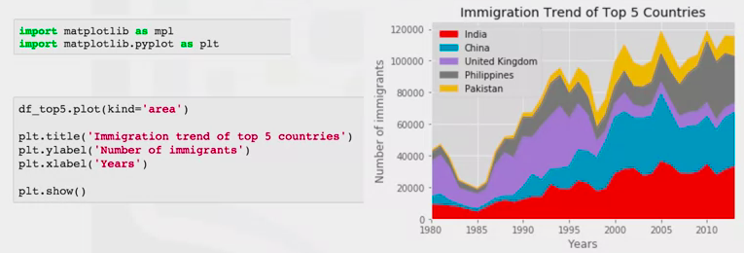

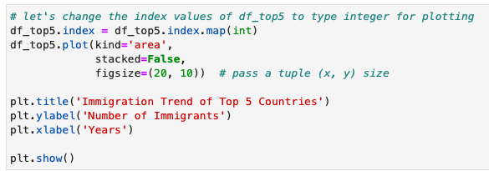

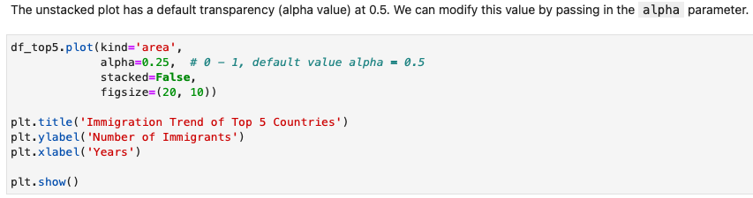

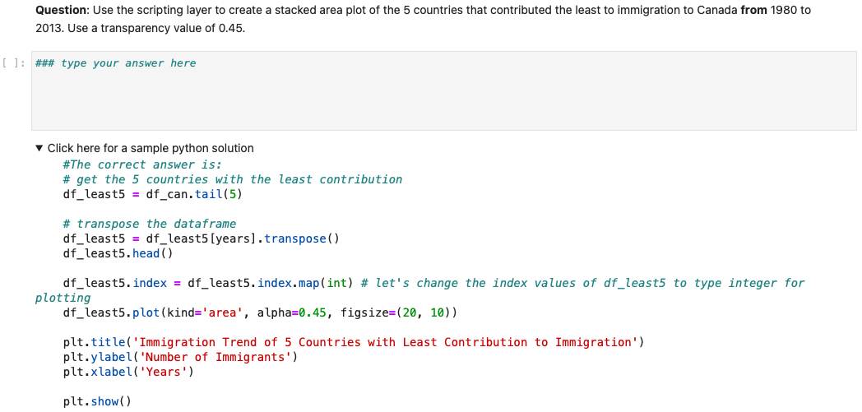

Histograms

1. A way of representing the frequency distribution of a variable
   1. Partitions the spread of numeric data into bins
   2. Assigns each data point in a dataset to a bin
   3. Counts the number of data points assigned to each bin
   4. The vertical axis is the number of data points in each bin

Generating Histograms

1. Country name becomes the index of each row
2. Add an extra column of cumulative sum of each country

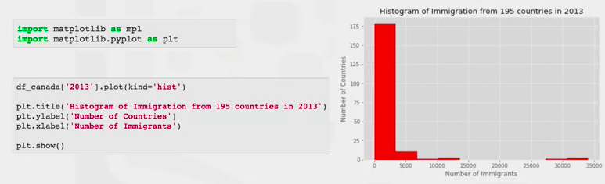

1. Bins are not aligned with the tick marks on the horizontal axis
2. To fix this:
   1. Import numpy library
   2. Call Numpy histogram function –
   3. This will partition the spread into 10 bins of equal width
   4. Compute the number of data points that fall into each bin
   5. And return the frequency of each bin (“count”) and the bin edges (“bin_edges”)
   6. Pass the bin_edges as an additional function

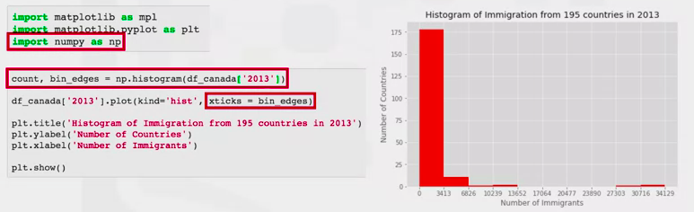

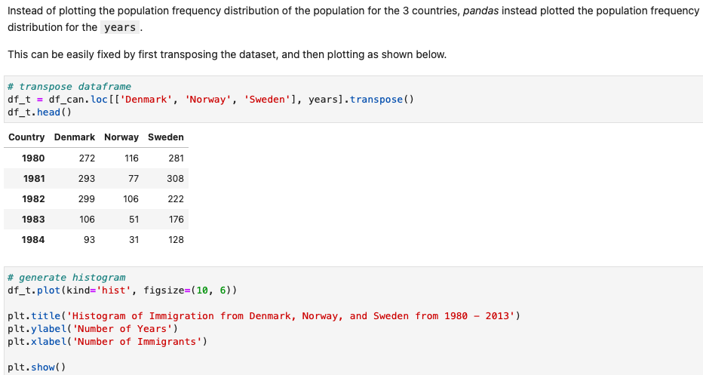

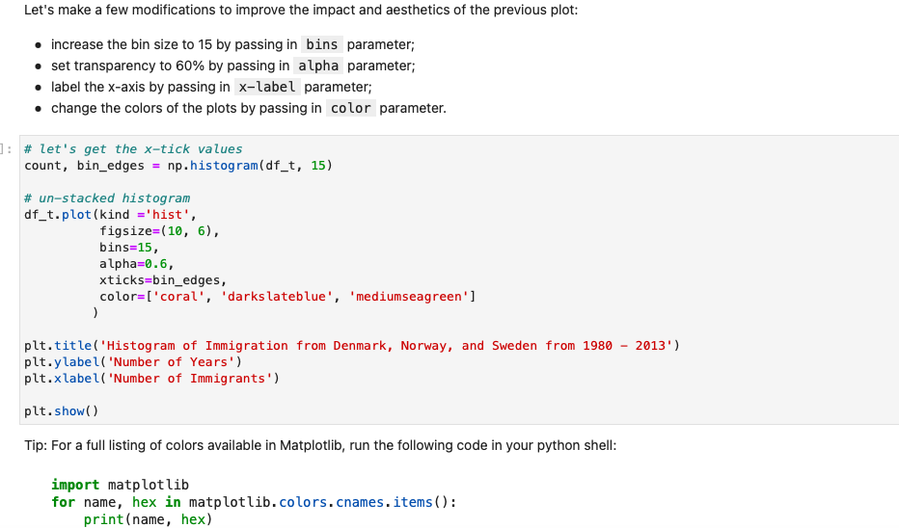

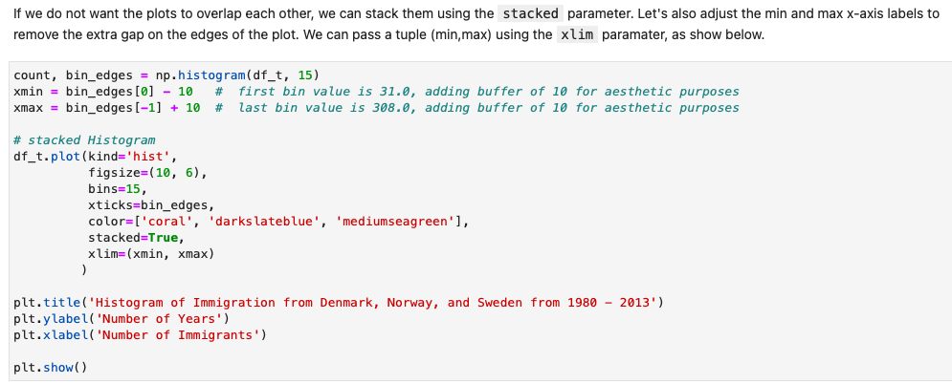

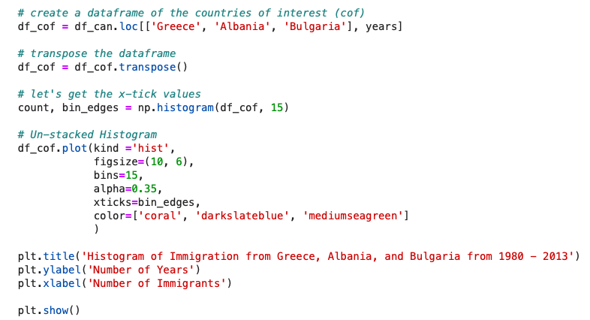

Bar Charts

1. Commonly used to compare the values of a variable at a given point in time

Generating Bar Charts

1. Process the dataframe so the country name becomes the index of each row
2. Add an extra column of cumulative sum of each country
   1. Import matplotlib
   2. Create new DF (df_Iceland) which excludes totals

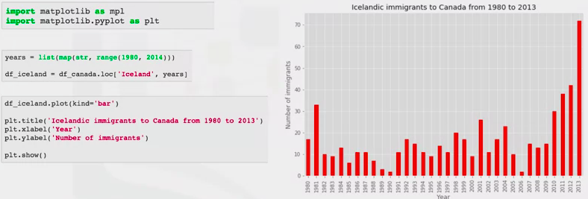

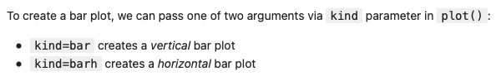

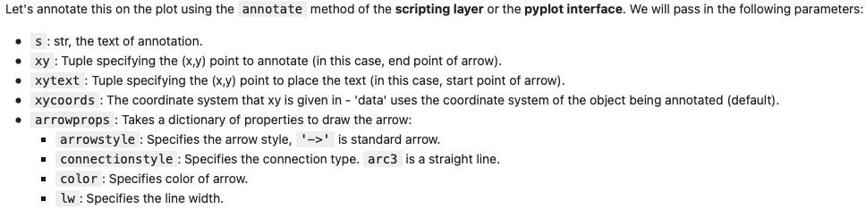

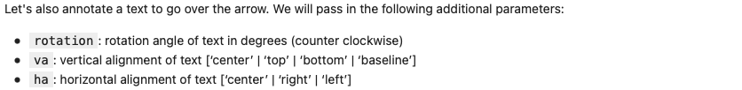

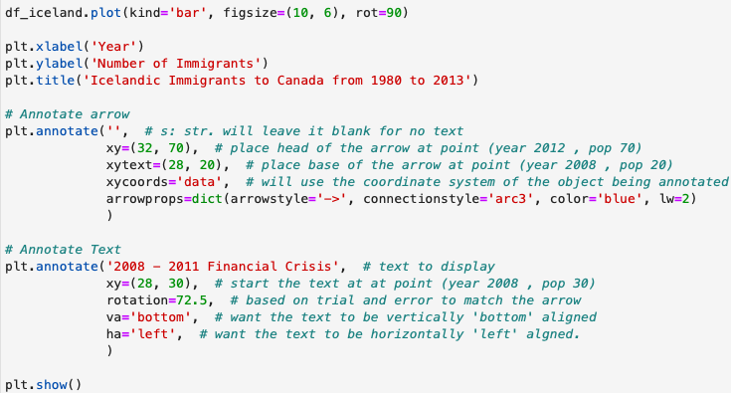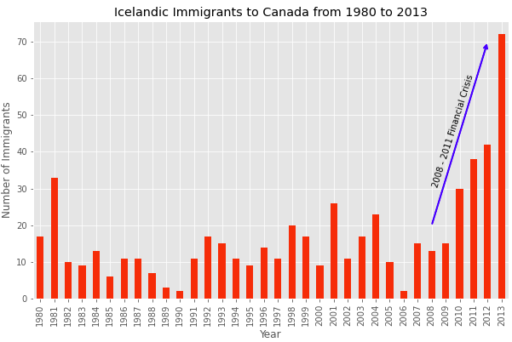

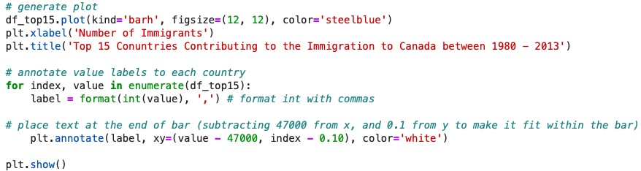

Pie Charts

1. Circular statistical graphic divided into slices to illustrate numerical proportion
2. Process the dataframe so the country name becomes the index of each row
3. Add an extra column of cumulative sum of each country

Generating a Pie Chart

1. Group data by continent (pandas)
2. Call pandas group by function and sum the number of immigrants that belong to the same continent

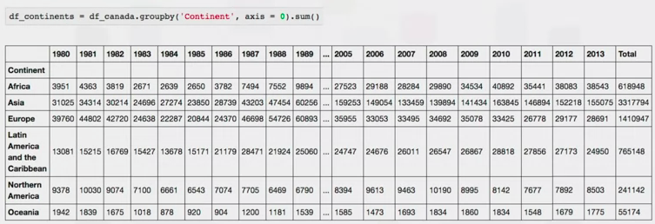

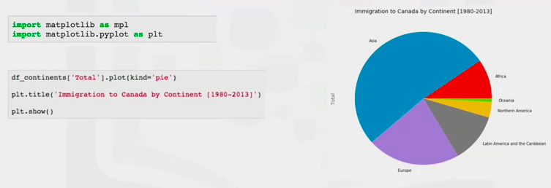

[www.surveygizmo.com/resources/blog/pie-chart-or-bar-graph/](http://www.surveygizmo.com/resources/blog/pie-chart-or-bar-graph/) (flaws of pie charts)

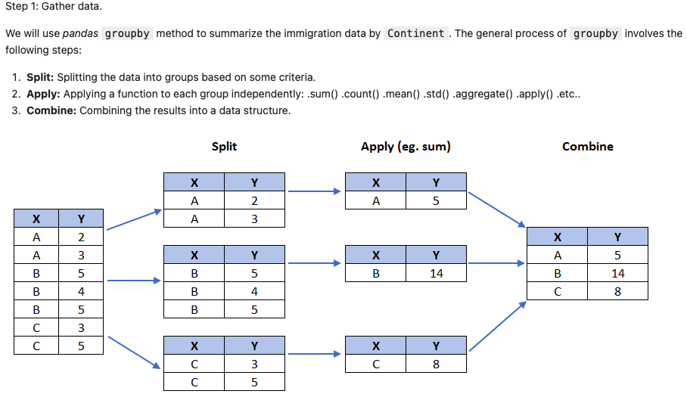

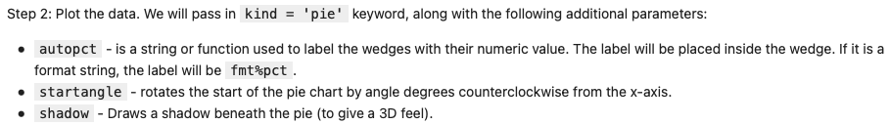

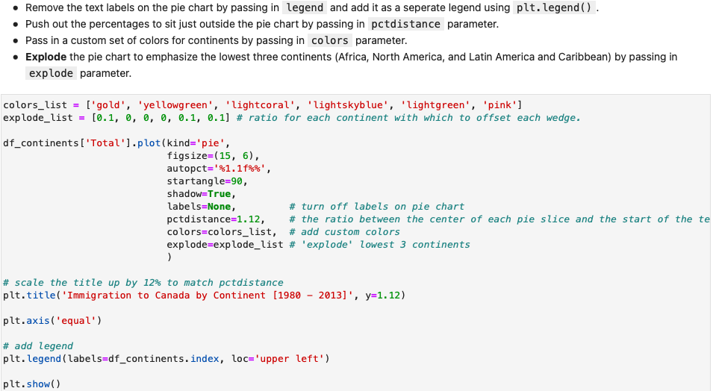

Box Plots

1. Way of statistically representing data through 5 different dimensions
   1. Minimum: Value = - 1.5*IQR (inter quartile range)
   2. First quartile: 25% of the sorted data
   3. Median: Median of the sorted data
   4. Third Quartile: 75% of the sorted data
   5. Maximum: 3rd quartile + 1.5 * IQR
   6. Outliers

Creating the Box Plot with Matplotlib

1. Process the dataframe so the country name becomes the index of each row
2. Add an extra column of cumulative sum of each country
3. Import matplotlib and pyplot
   1. Create new df_ and exclude the column total using ‘Years’ variable
   2. Transpose resulting df_ to the correct format

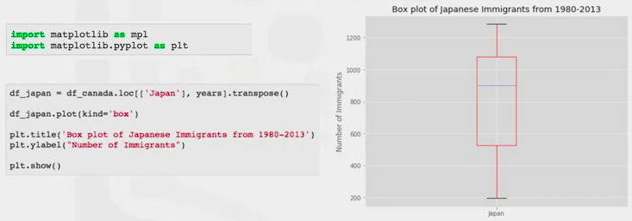

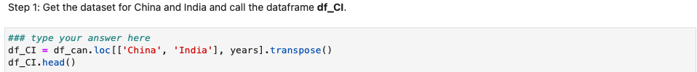

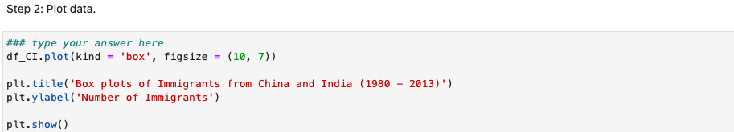

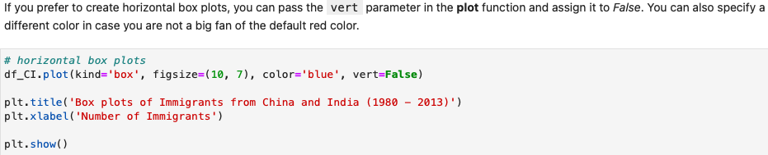  
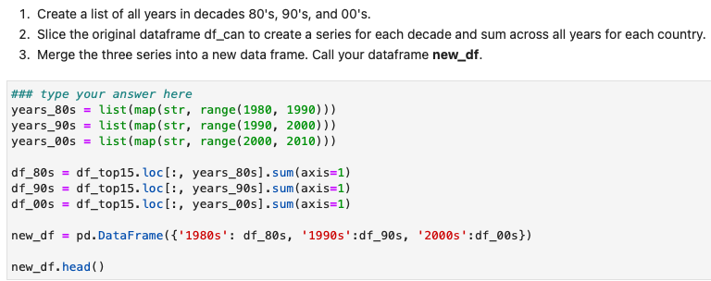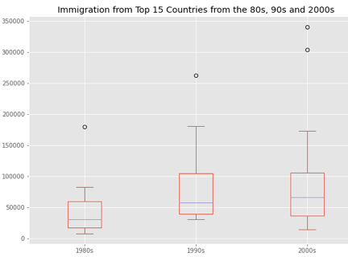

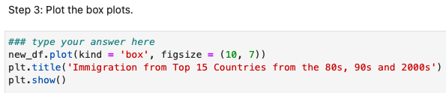

Subplots

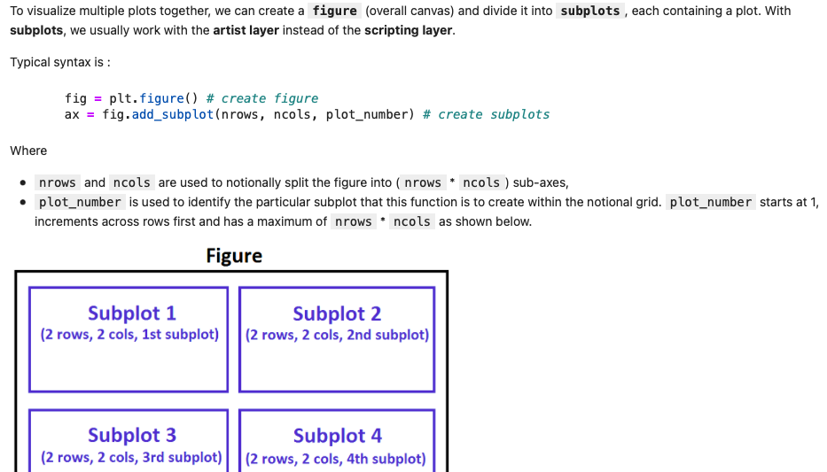

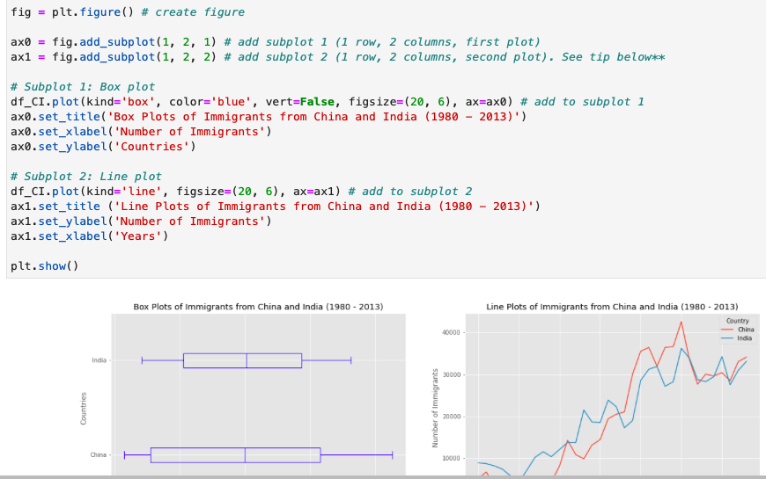

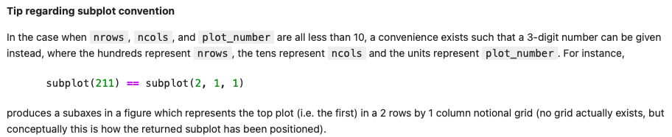

Scatter Plots

1. Displays values, typically 2 variables against each other
2. Usually, a dependent variable plotted against an independent variable in ord to determine if any correlation exists

Generating a Scatter Plot

1. Process the dataframe so the country name becomes the index of each row
2. Add an extra column of cumulative sum of each country
3. Create a new DF_ that shows each year and total number of immigrations
4. Import matplotlib and pyplot
5. Need to call ‘kind’ as well as the x and y axes

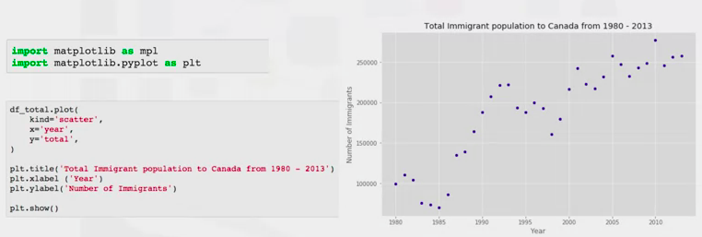

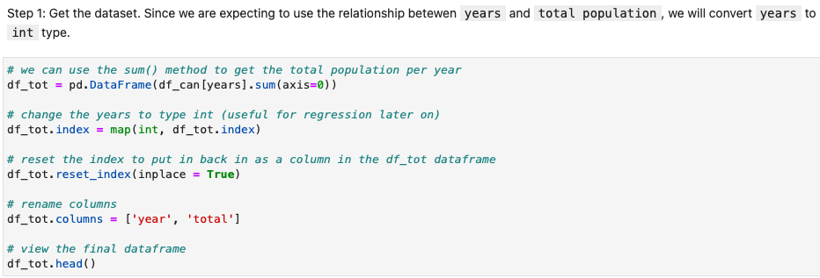

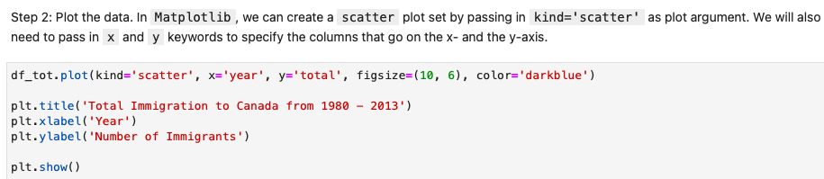

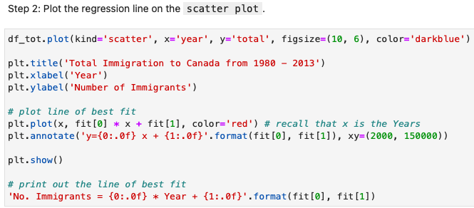

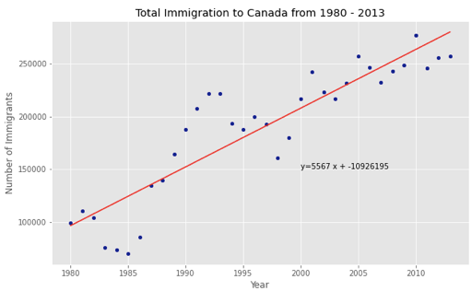

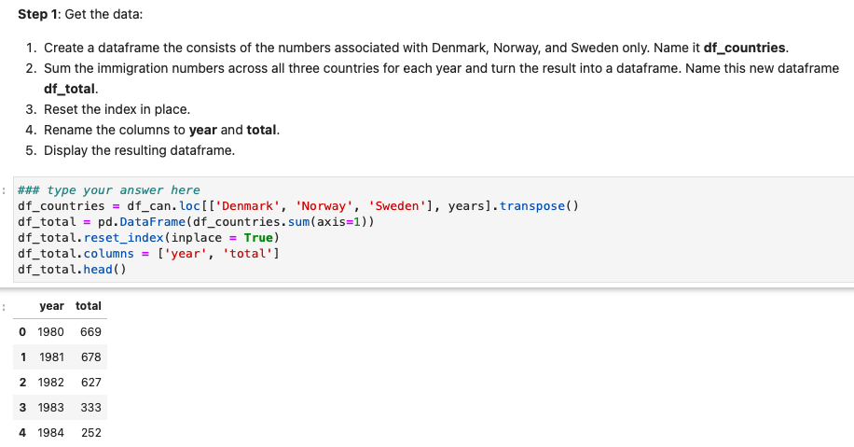

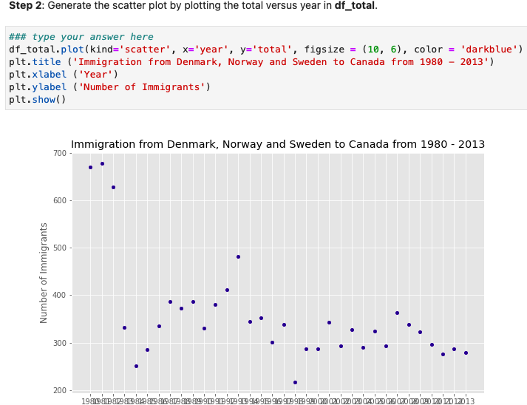

Bubble Plots

1. Scatter plot that displays three dimensions of data (x, y, z)
2. Size of the bubble is determined by the third variable Z (a.k.a weight)
3. In matplotlib we can pass in an array or scalar to the parameter “s” to plot(), that contains the weight of each point

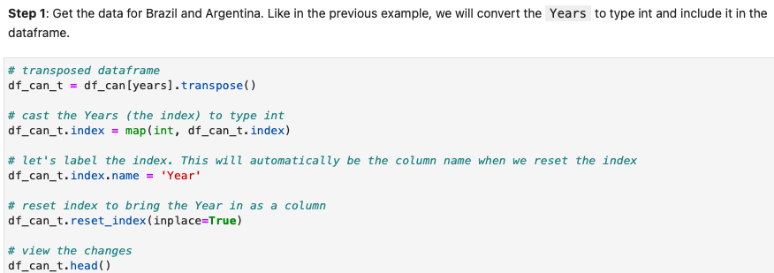

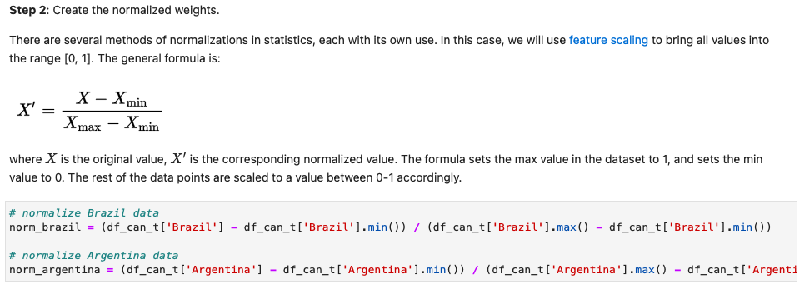

Step 3

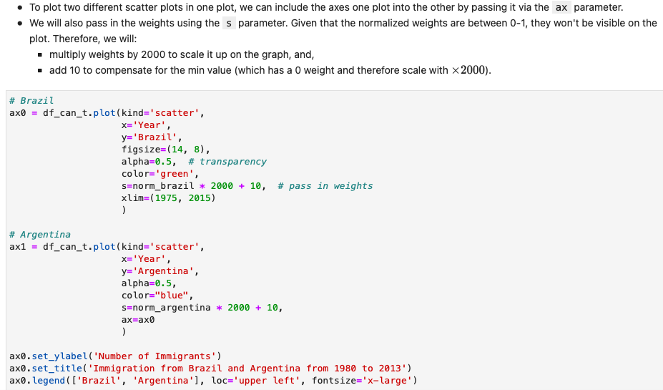

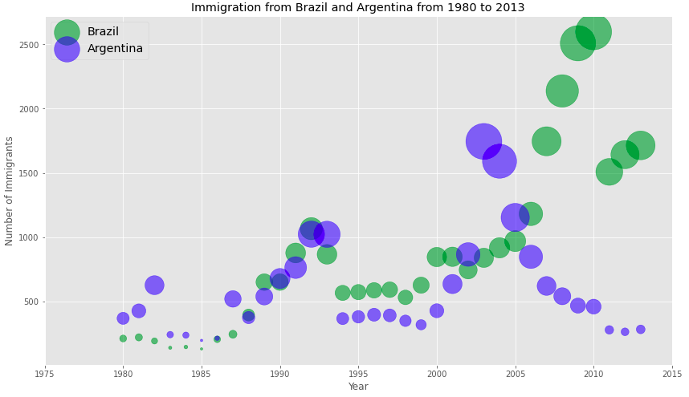

Waffle Charts

1. Way to visualize data in relation to a whole or to highlight progress against a given threshold
2. Created to display progress toward goals
3. Contribution of each variable is transformed into a number of tiles, proportionate to the variable’s contribution to the total

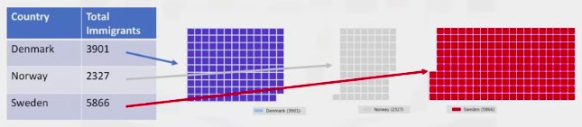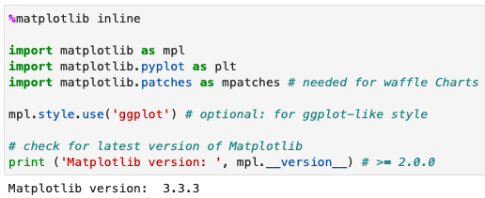

1. Matplotlib does not have a built-in funtion for waffel charts – one must create their own python program

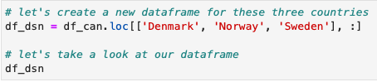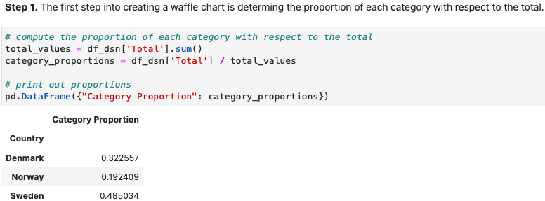

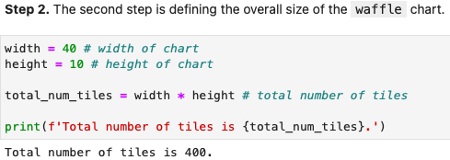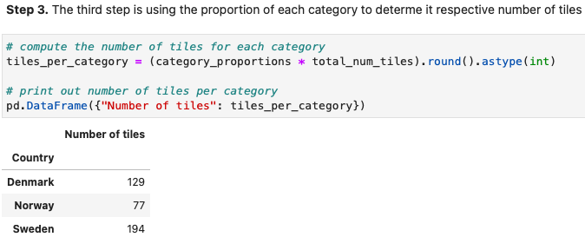

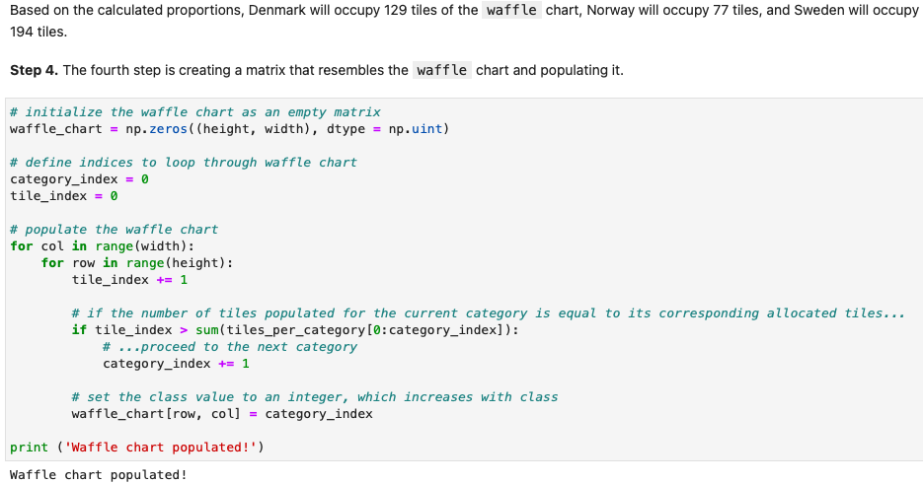

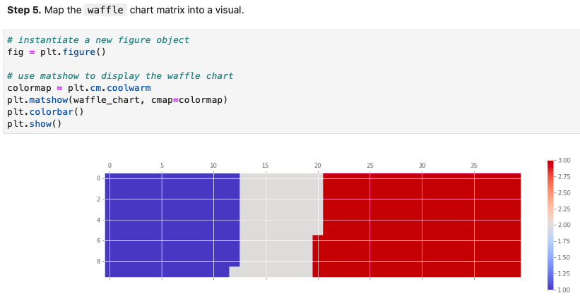

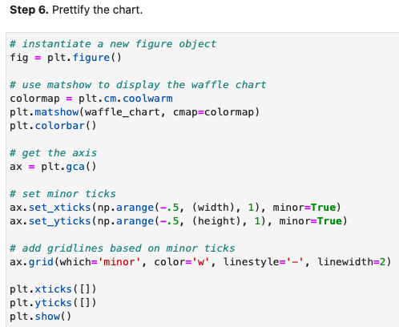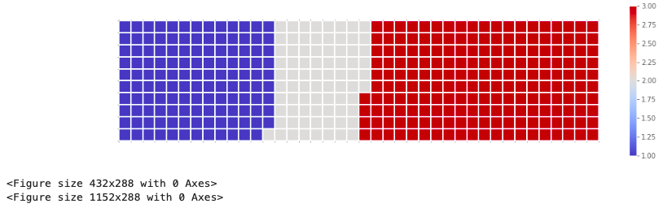

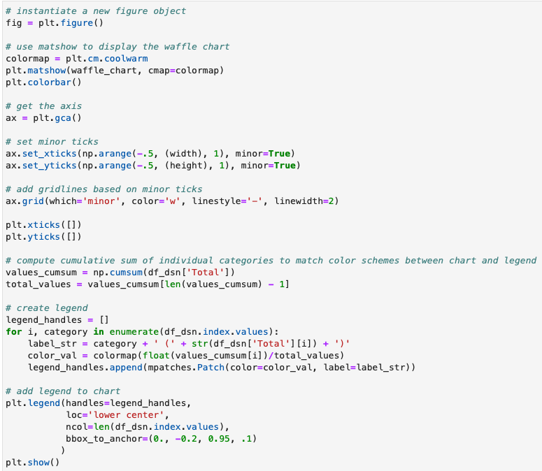

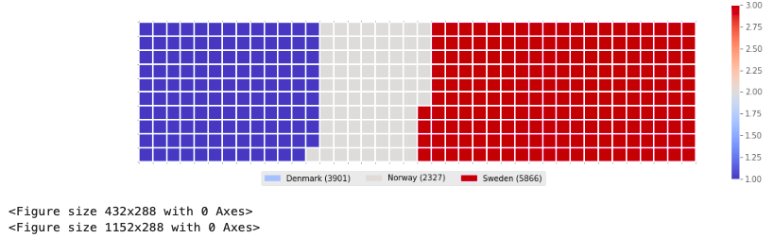

**Simplify a Waffle Chart**

1. Categories: Unique categories or classes in dataframe
2. Values: Values corresponding to categories or classes
3. Height: Defined height of waffle chart
4. Width: Defined width of wattle chart
5. Colormap: Colormap class
6. Value_Sign: Use this parameter to address signs associated with values %$. Value_sign has a default of empty string

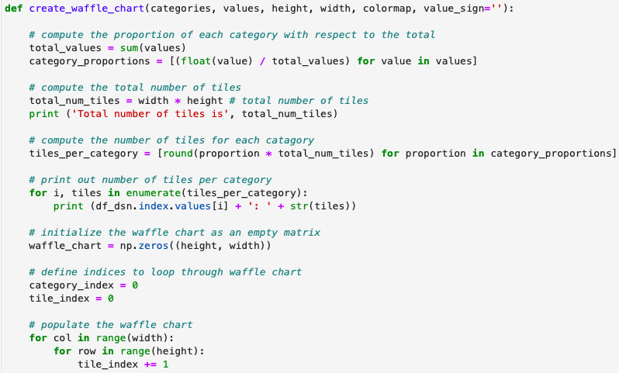

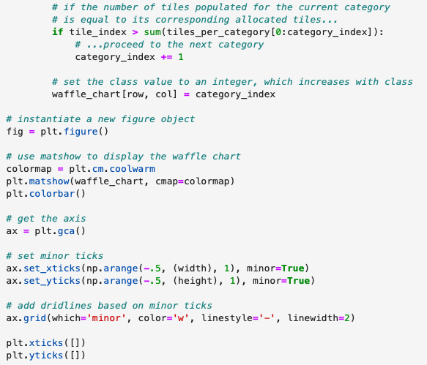

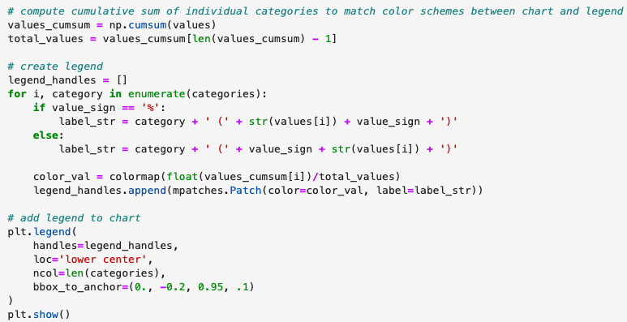

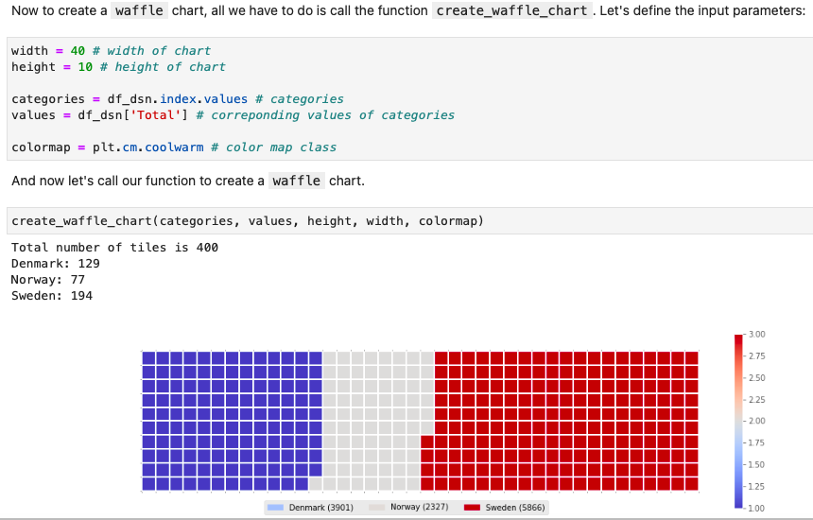

Word Clouds

1. A depiction of the frequency (importance) of different words in textual data
2. The more a word appears, the bolder and larger that word will be
3. Easy to assign a topic to textual data
4. Matplotlib does not have a function to generate word clouds (open source Andrea Muller)



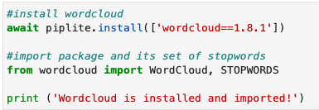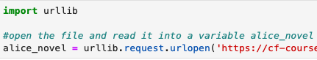



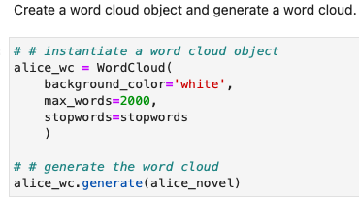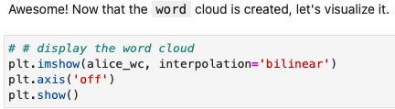

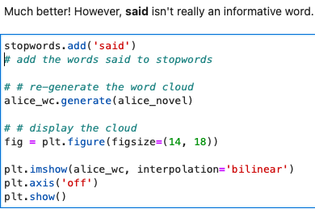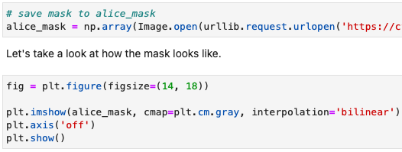

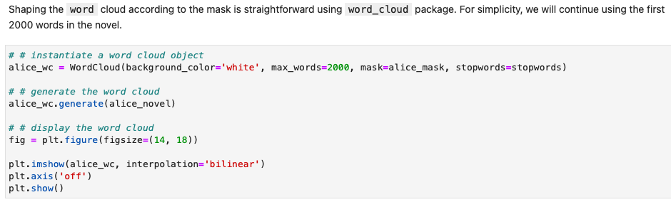

**Making a Word Cloud with immigration data**

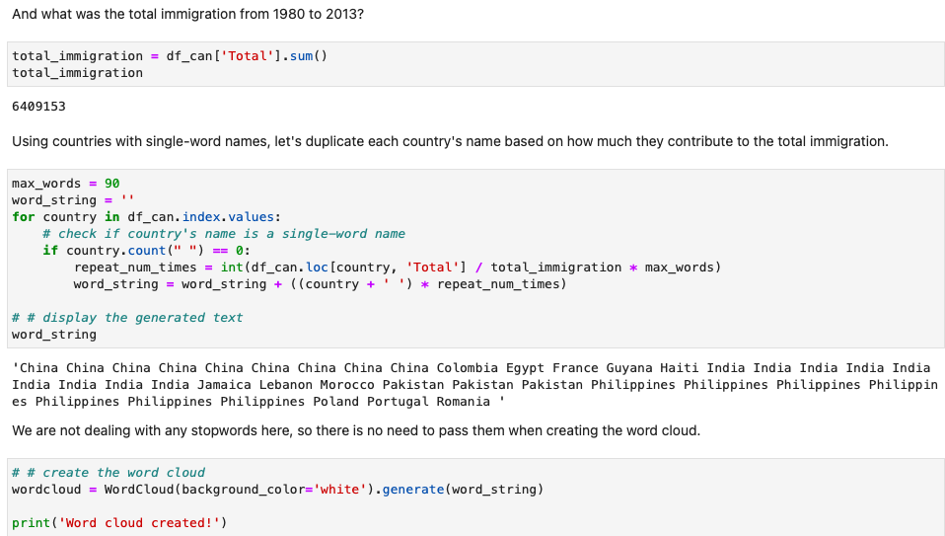

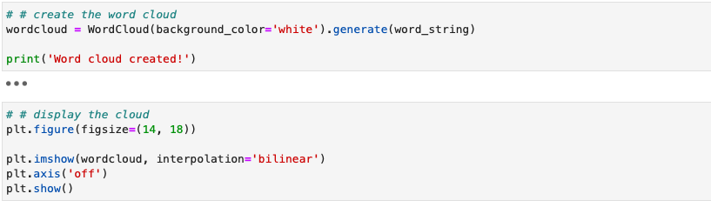

Seaborn and Regression Plots

1. Seaborn: visualization library in Python
2. Based on Matplotlib – designed as a high level program for drawing graphics and plots
3. With Seaborn you can create visuals with 5 times less code than matplotlib

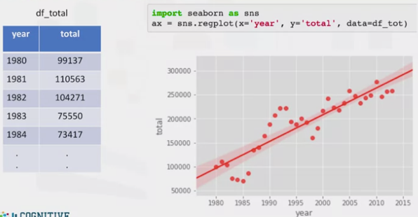95% confidence interval.

Accepts additional parameters for any personalization  
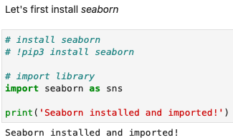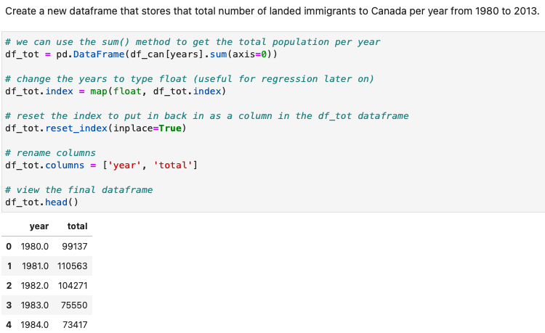  
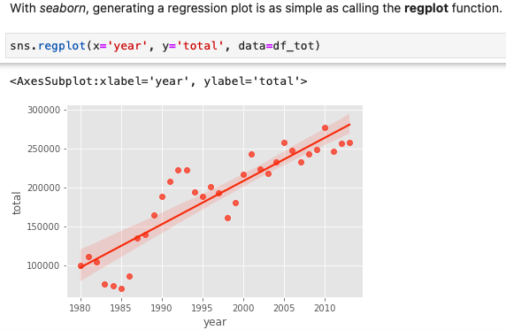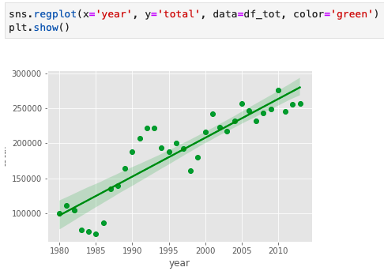  
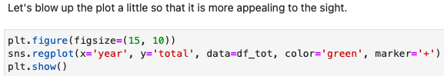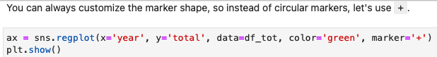

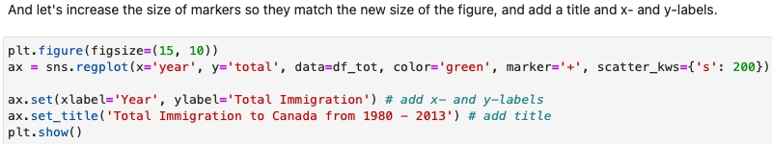

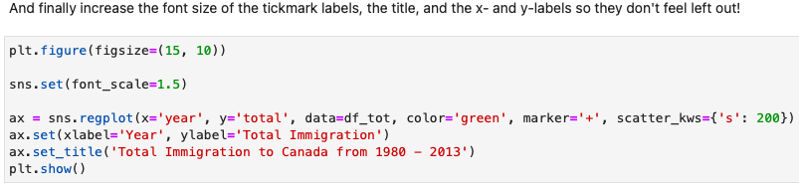

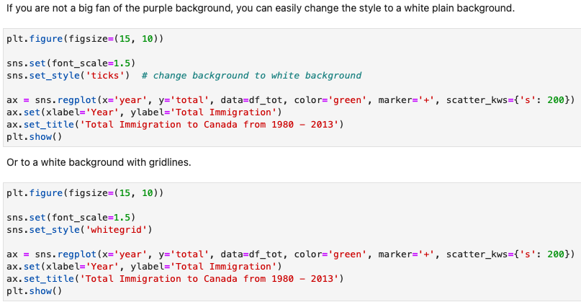

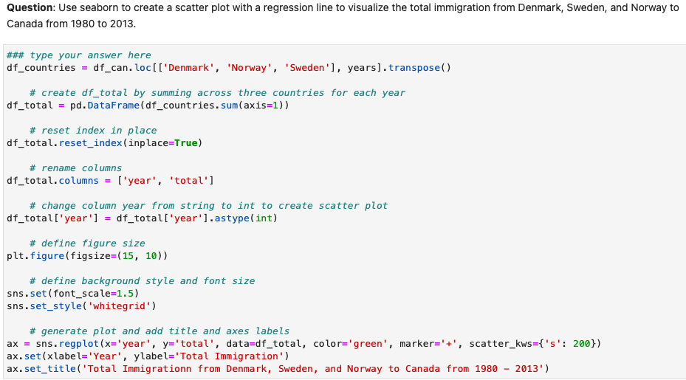

Folium

1. Powerful python library that helps create several types of Leaflet maps
2. Built to help people visualize geospatial data
3. Can create a map of any location in the world as long as you know the latitude and longitude values
4. Binding of data to a map for choropleth visualizations as well as passing visualizations as markers on the map
5. Built in tilesets from OpenStreetMaps, Mapbox, and Stamen, and supports custom tilesets with Mapbox API keys

Creating a World Map

1. 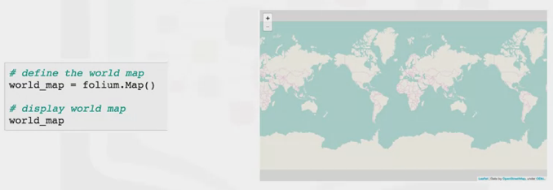 Allows for zooming in and out, showing borders and countries

Creating a Map of Canada

1. You can set the initial start parameter, but this parameter can be adjusted

Map Styles – Stamen Toner

1. Great for visualizing rivers and coastal zones

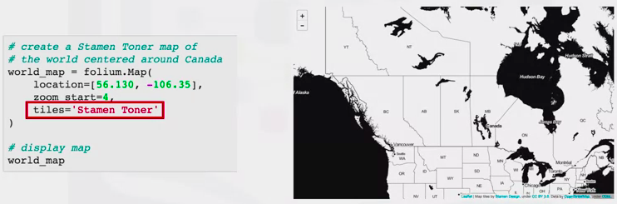

Map Styles – Stamen Terrain

1. Visualizing hill shading and natural vegetation markers

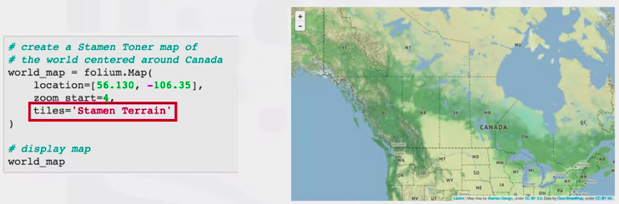

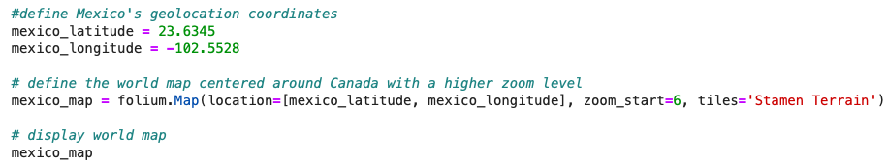

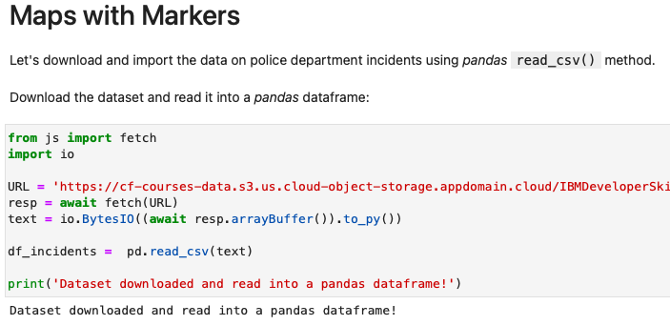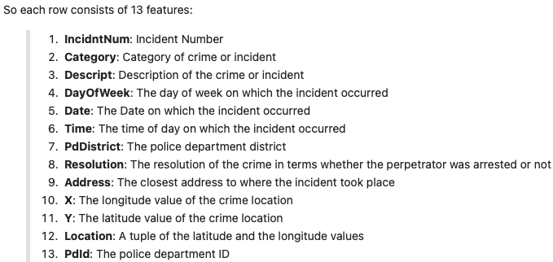

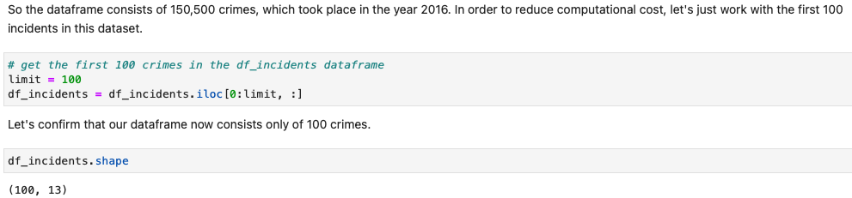

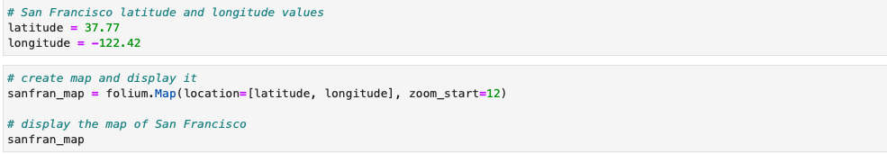

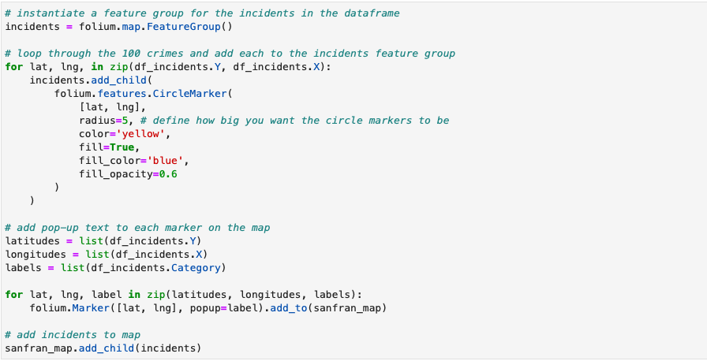

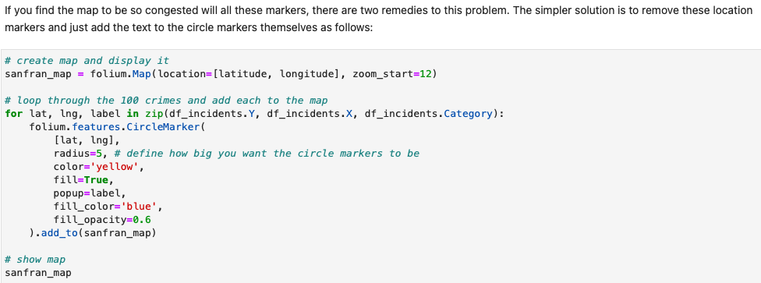

Maps with Markers

1. Create a feature group: Empty grouping
2. Children populate the feature group
3. Once the children have been added, you add the feature group to the map
4. Add the marker and pop-up parameter to add text to the marker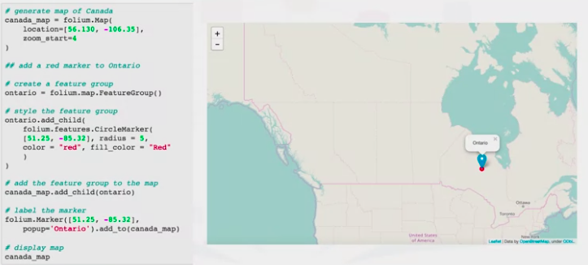

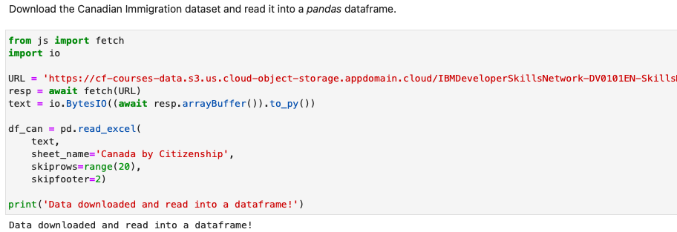

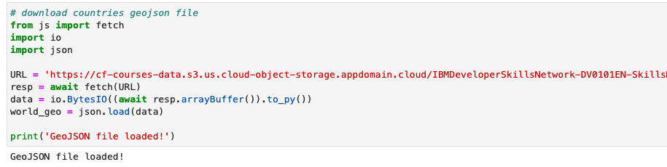

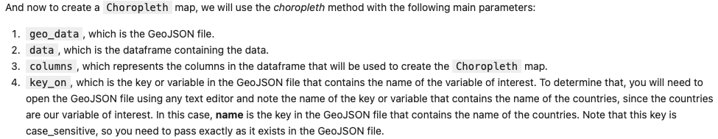

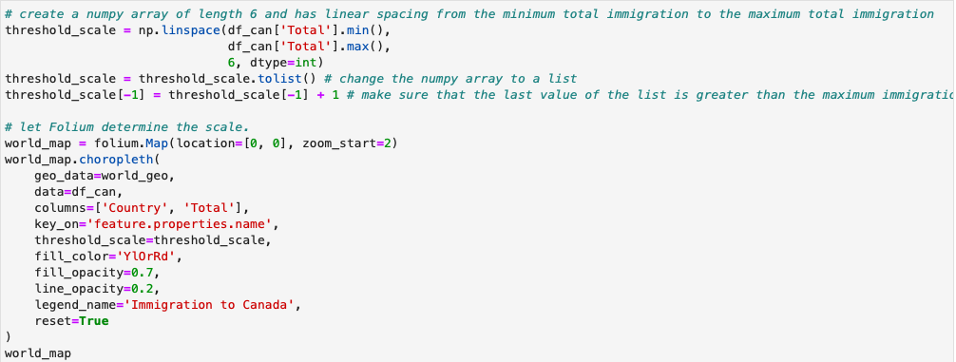

Choropleth Maps

1. Thematic map where an area is shaded or patterned in proportion to a statistical variable that is displayed on the map (e.g. population density)
2. Folium requires a geojson file, listing each country and details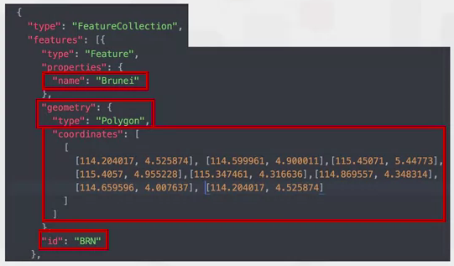

Creating a Choropleth Map

1. Titles: Mapbox Bright
2. To convert the map into a choropleth map:
   1. First define a variable that links to the geojson file
   2. Then apply the choropleth map using the columns ‘country’, ‘key’

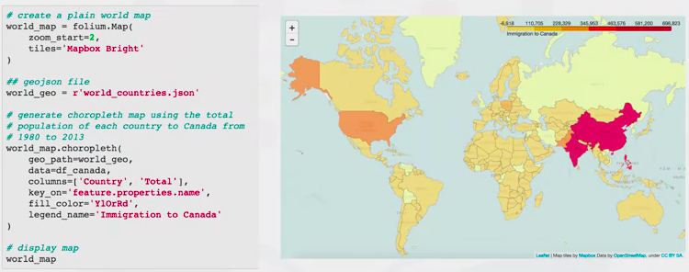

**Week 4 – CREATING DASHBOARDS WIH PLOTLY AND DASH**

Dashboard Overview

1. Real-time visuals
2. Understand busines moving parts
3. Visually track, analyze and display key performance indicators (KPI) in one central location
4. Helps making informed business questions – best dashboards answer business questions
5. 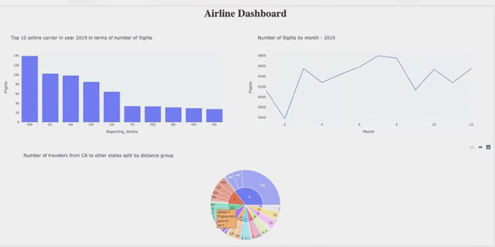Report on real-time data

Web-based Dashboarding

1. Dash is a python framework for building web-analytic applications
2. It is written on top of Flask, Plotlyjs and Reactjs
3. Panel: Works with visualizations from Bokeh, Matplotlib, Hollow-views
   1. Can be used in Juypter Notebooks
   2. Can be used in stand-alone apps and dashboards, allowing you to switch between those contexts as needed
4. Voila: turns jupyter notebooks into stand-alone web applications
   1. Can be used with templates like JupyterFlex and Voila Beautify
5. Streamlit: Can turn data scripts into sharable web apps with three main applications
   1. Embrace python scripting
   2. Treat widgets as variables
   3. Reuse data and computation
6. Bokeh: Plotting library, widget and app library.
   1. Acts as a server for both plots and dashboard
   2. Panel is built on Bokeh
7. Ipywidgets: Provides an array of Jupyter compatible widgets and is supported by many python librarys.
8. Sharing a dashboard requires a separate deployable server like Voila
9. Matplotlib: Create static, animated and interactive visualizations in Python
10. Bowtie: Build dashboards in pure python
11. Flask: Python backed webserver, used to build arbitrary websites , including those with Python plots that function as flask dashboards

Plotly

1. Interactive, open-source plotting library
2. Supports over 40 unique chart types
3. Available in R, Python and Javascript
4. Built on top of Javascript library and includes statistical, financial, maps, scientific and 3-D chart types
5. Visualizations can be displayed in Jupyter notebook, saved to html files, or can be used in developing python-built web applications using Dash
6. Plotly Graph Objects: Low-level interface to figures, traces and layout
   1. Ploty.graph_objects.figures
   2. Provides automatically generated hierarchy of classes – figures, traces and layout – called graph_objects.
7. Plotly Express: high-level wrapper
   1. Recommended starting point for creating most common figures by plotly using a more simple syntax. Uses graph objects internally.

Plotly.graph_objects

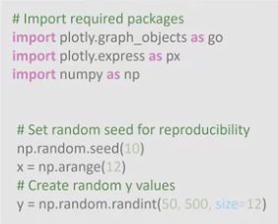 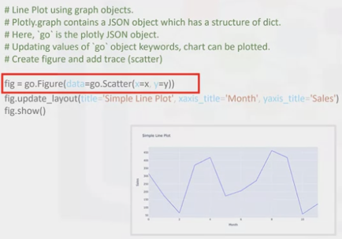

Plotly Express

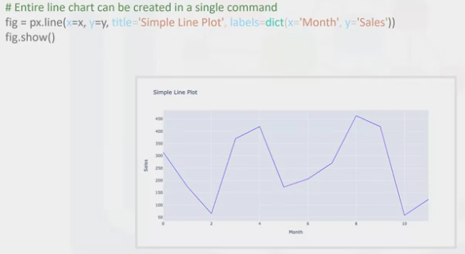

<https://plotly.com/python/getting-started/>

<https://plotly.com/python/graph-objects/>

<https://plotly.com/python/plotly-express/>

<https://plotly.com/python-api-reference/>

<https://images.plot.ly/plotly-documentation/images/plotly_js_cheat_sheet.pdf>

<https://community.plotly.com/c/api/5>

<https://plotlygraphs.medium.com/>

<https://developer.ibm.com/exchanges/data/>

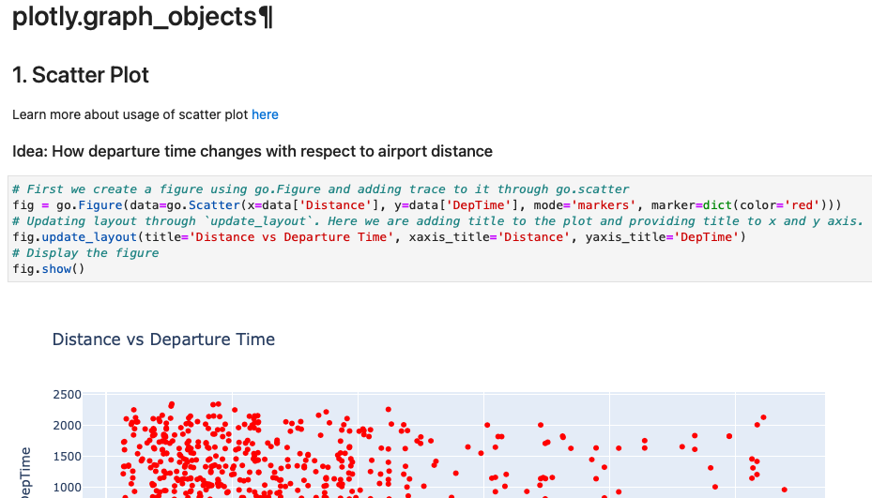

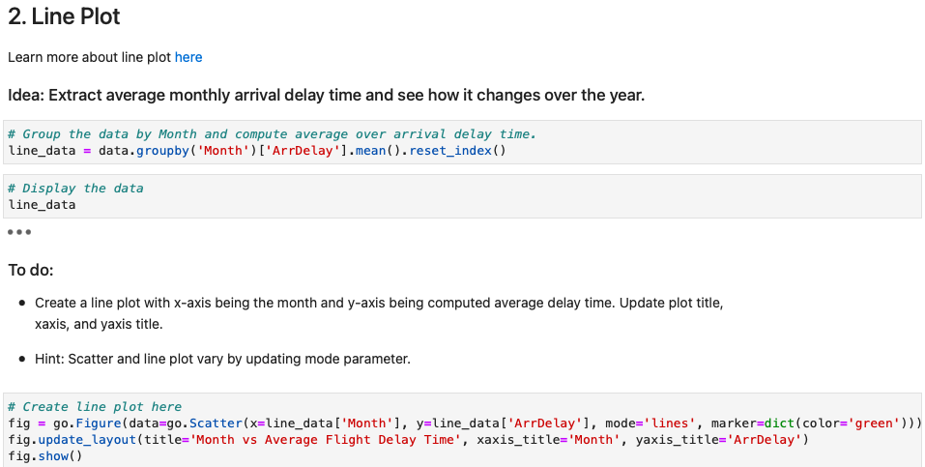

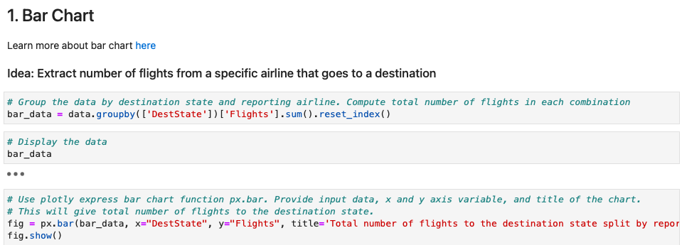

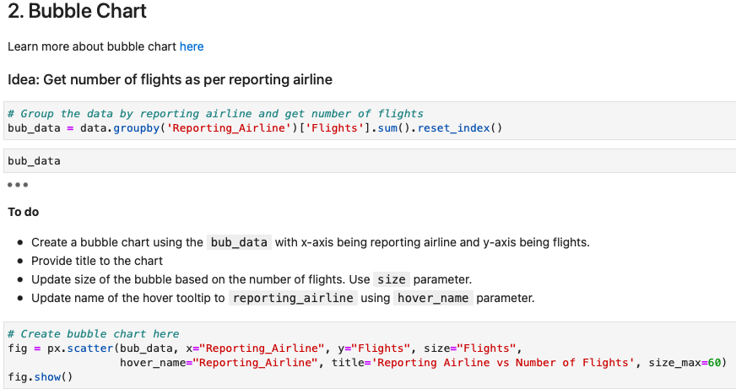

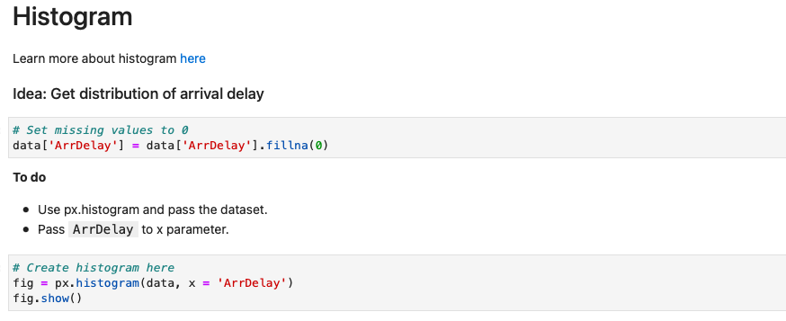

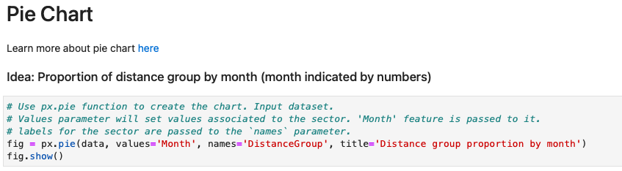

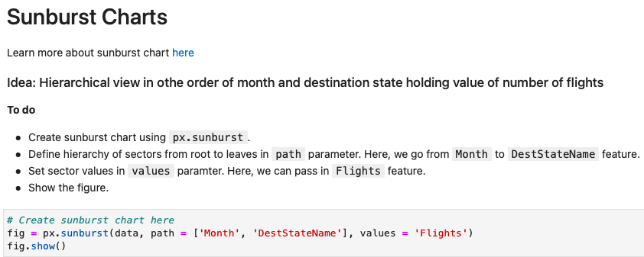

**INTRODUCTION TO DASH**

1. Open-source user Interface Python library from Plotly used to create reactive web-based applications
2. Dash applications are webservers running Flask, communicating JSON packets over http requests
3. Dash’s frontend renders components using reactJS
4. Easy to build GUI
5. Declarative and reactive
6. Rendered in web browser and can be deployed to servers
7. Inherently cross-platform and mobile ready

Dash Components

1. Core Components
   1. Import dash_core_components as dcc
2. HTML Components
   1. Import dash_html_components as html

HTML Component

1. Component for every HTML tag
2. Keyword arguments describe the HTML attributes
3. Keyword arguments describe style, classname and ID

Core Components

1. Higher-level components that are interactive and are generated with JavaScript, HTML and CSS through React.js library
2. Example: Creating a slider, input area, check items, datepicker, etc
3. 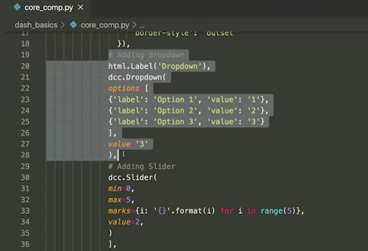For the dropdown use the dcc.dropdown components
4. Label will hold the dropdown display label nameand “value” will hold the value f the label
5. DCC.slider will hold the min and max

<https://dash.plotly.com/>

<https://dash.plotly.com/dash-core-components>

<https://dash.plotly.com/dash-html-components>

<https://community.plotly.com/c/dash/16>

<https://medium.com/plotly/tagged/dash>

Make Dashboards Interactive

1. Callback: Python function that is automatically called by Dash whenever an input component’s property changes
2. Decorator: @app.callback
3. Whenever there is a change in the input component value, the callback function wrapped by the decorator is called, followed by the update to the output component “children” in the application layout

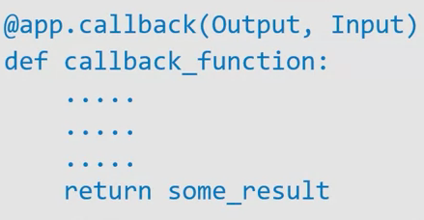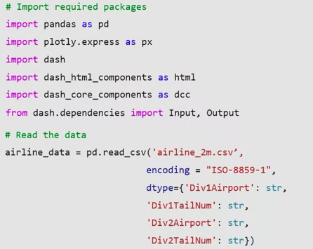

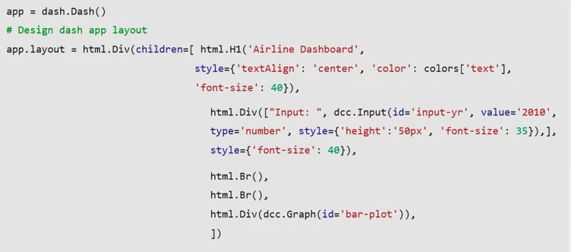

1. Import the input and output – read the airline data into the pandas data frame
2. Load the dataframe at the start of the app. It can be read inside the callback function
3. Start designing the dash application layout by adding components
   1. Provide the title to the app using the html.H1 (heading) and style it using the style parameter
   2. Add an html division and text input core component
   3. 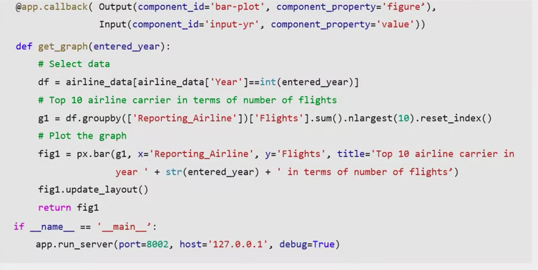Add a division with a graph core component (has bar-plot as ID)
   4. app.callback – call back decorator
   5. Define the callback function “get_graph”
   6. Lastly run the application

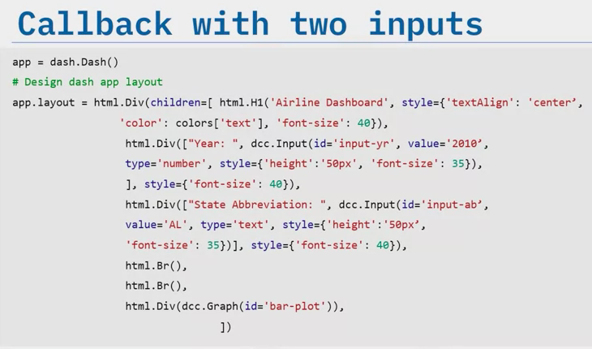

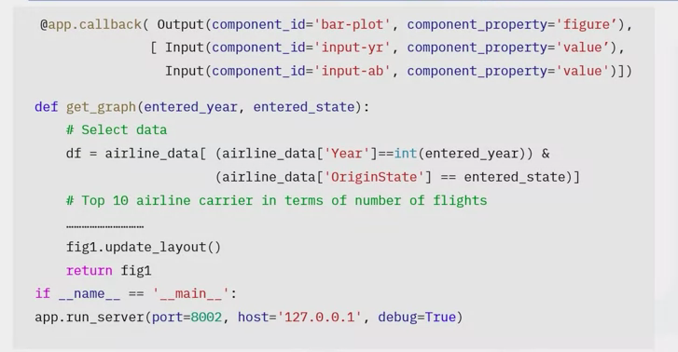

1. Add a division with one more text input with the component id (input – ab)
2. Add the new input and component id to the decorator inside the list
3. Define callback function get_graph

<https://realpython.com/primer-on-python-decorators/>

<https://www.python.org/dev/peps/pep-0318/#current-syntax>

<https://dash.plotly.com/basic-callbacks>

<https://dash-gallery.plotly.host/Portal/>

<https://plotly.com/dash-community-components/>

# Import required libraries

import pandas as pd

import plotly.graph_objects as go

import dash

import dash_html_components as html

import dash_core_components as dcc

from dash.dependencies import Input, Output

# Read the airline data into pandas dataframe

airline_data = pd.read_csv('https://cf-courses-data.s3.us.cloud-object-storage.appdomain.cloud/IBMDeveloperSkillsNetwork-DV0101EN-SkillsNetwork/Data%20Files/airline_data.csv',

encoding = "ISO-8859-1",

dtype={'Div1Airport': str, 'Div1TailNum': str,

'Div2Airport': str, 'Div2TailNum': str})

# Create a dash application

app = dash.Dash(__name__)

# Get the layout of the application and adjust it.

# Create an outer division using html.Div and add title to the dashboard using html.H1 component

# Add a html.Div and core input text component

# Finally, add graph component.

app.layout = html.Div(children=[html.H1(),

html.Div(["Input Year", dcc.Input(),],

style={}),

html.Br(),

html.Br(),

html.Div(),

])

# add callback decorator

@app.callback( Output(component_id='line-plot', component_property='figure'),

Input(component_id='input-year', component_property='value'))

# Add computation to callback function and return graph

def get_graph(entered_year):

# Select 2019 data

df = airline_data[airline_data['Year']==int(entered_year)]

# Group the data by Month and compute average over arrival delay time.

line_data = df.groupby('Month')['ArrDelay'].mean().reset_index()

fig = go.Figure(data=go.Scatter(x=line_data['Month'], y=line_data['ArrDelay'], mode='lines', marker=dict(color='green')))

fig.update_layout(title='Month vs Average Flight Delay Time', xaxis_title='Month', yaxis_title='ArrDelay')

return fig

# Run the app

if __name__ == '__main__':

app.run_server()# Import required libraries

import pandas as pd

import plotly.graph_objects as go

import dash

import dash_html_components as html

import dash_core_components as dcc

from dash.dependencies import Input, Output

# Read the airline data into pandas dataframe

airline_data = pd.read_csv('https://cf-courses-data.s3.us.cloud-object-storage.appdomain.cloud/IBMDeveloperSkillsNetwork-DV0101EN-SkillsNetwork/Data%20Files/airline_data.csv',

encoding = "ISO-8859-1",

dtype={'Div1Airport': str, 'Div1TailNum': str,

'Div2Airport': str, 'Div2TailNum': str})

# Create a dash application

app = dash.Dash(__name__)

app.layout = html.Div(children=[ html.H1('Airline Performance Dashboard',

style={'textAlign': 'center', 'color': '#503D36',

'font-size': 40}),

html.Div(["Input Year: ", dcc.Input(id='input-year', value='2010',

type='number', style={'height':'50px', 'font-size': 35}),],

style={'font-size': 40}),

html.Br(),

html.Br(),

html.Div(dcc.Graph(id='line-plot')),

])

# add callback decorator

@app.callback( Output(component_id='line-plot', component_property='figure'),

Input(component_id='input-year', component_property='value'))

# Add computation to callback function and return graph

def get_graph(entered_year):

# Select 2019 data

df = airline_data[airline_data['Year']==int(entered_year)]

# Group the data by Month and compute average over arrival delay time.

line_data = df.groupby('Month')['ArrDelay'].mean().reset_index()

fig = go.Figure(data=go.Scatter(x=line_data['Month'], y=line_data['ArrDelay'], mode='lines', marker=dict(color='green')))

fig.update_layout(title='Month vs Average Flight Delay Time', xaxis_title='Month', yaxis_title='ArrDelay')

return fig

# Run the app

if __name__ == '__main__':

app.run_server()

**pip3** install pandas dash

**python3** **dash_interactivity**.py

